**Adaboost classifier**

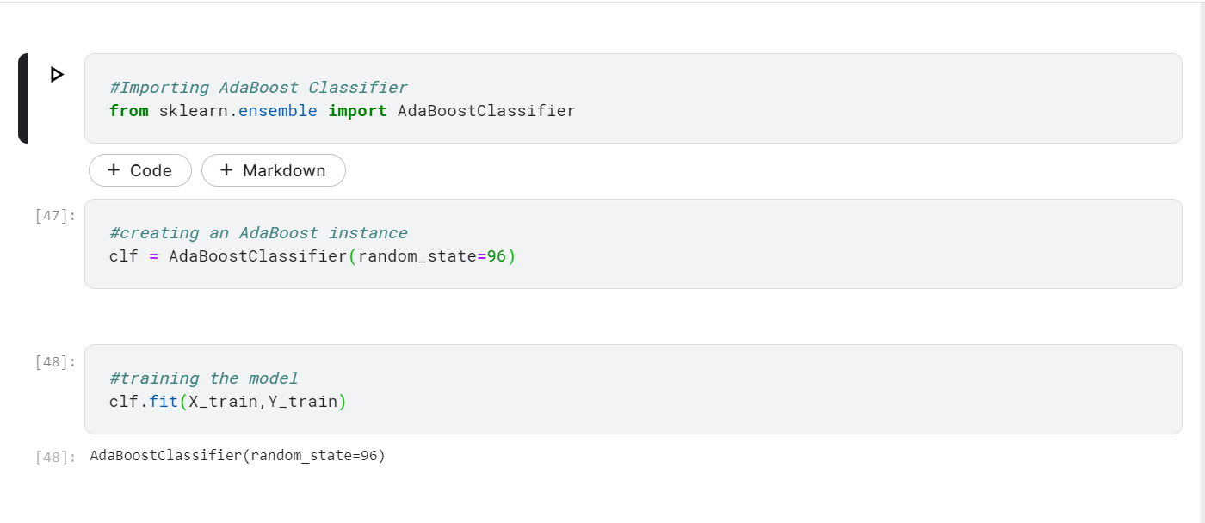

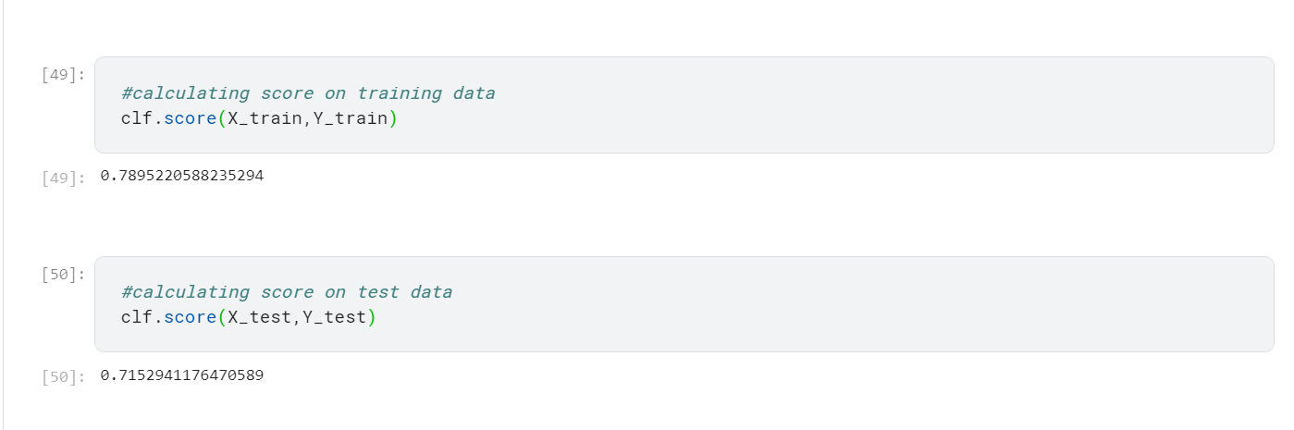

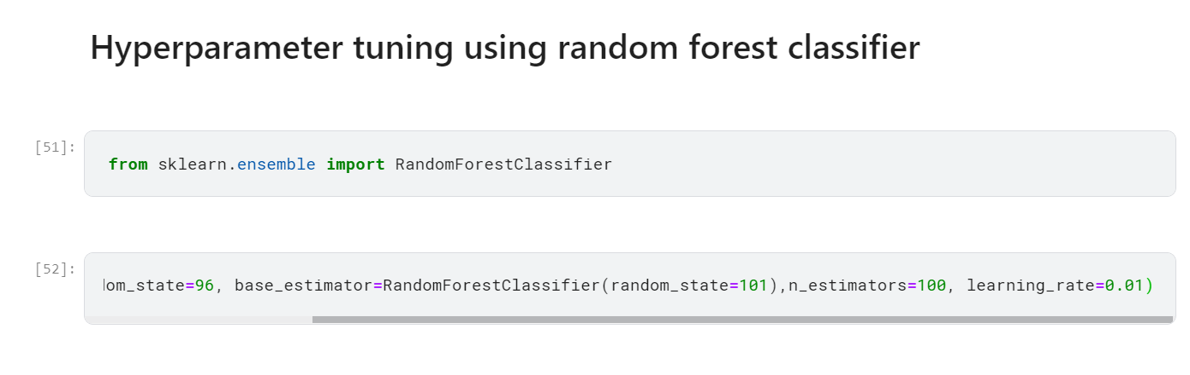

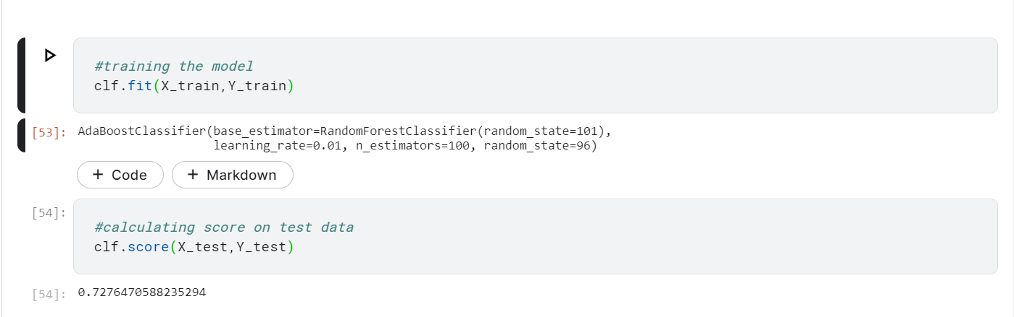

Initially accuracy for AdaBoost classifier: 71.53%

After hyperparameter tuning using random forest accuracy: 72.77%

**XGBoost Classifier**

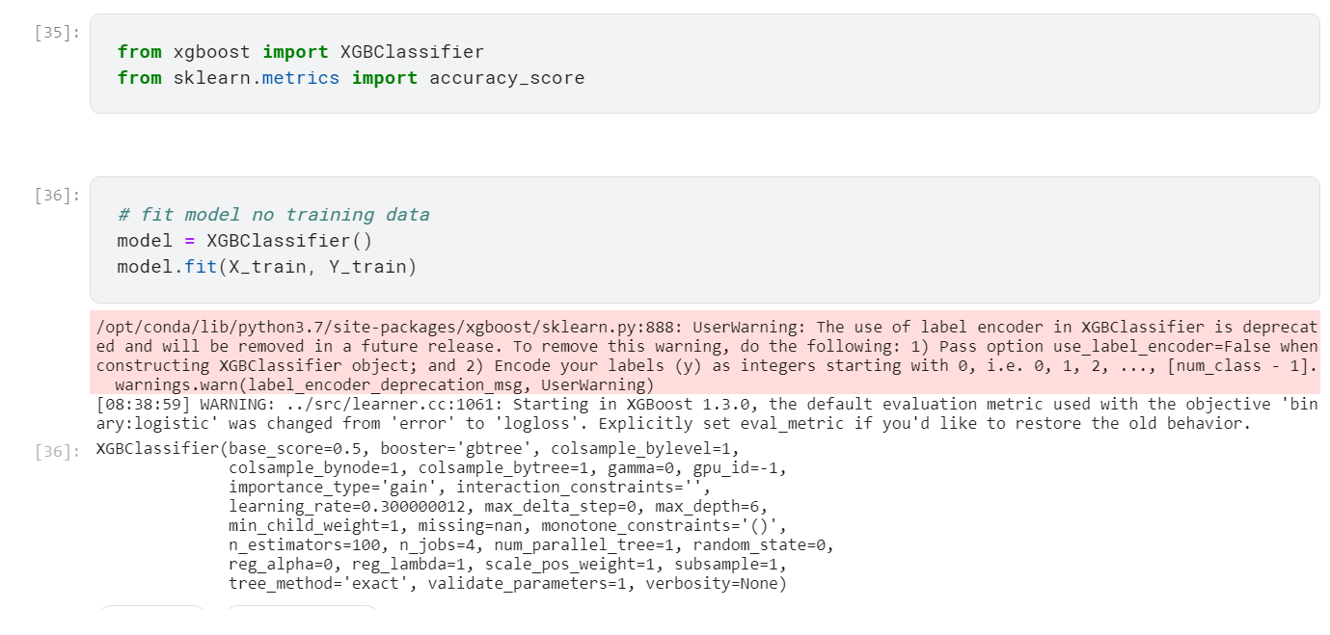

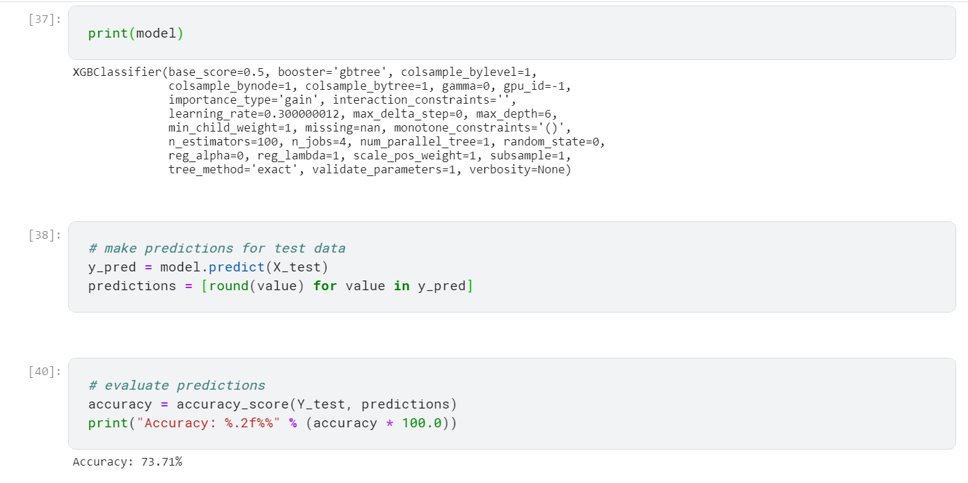

XGBoost Classifier gives an accuracy of 73.71%

**SGD Classifier**

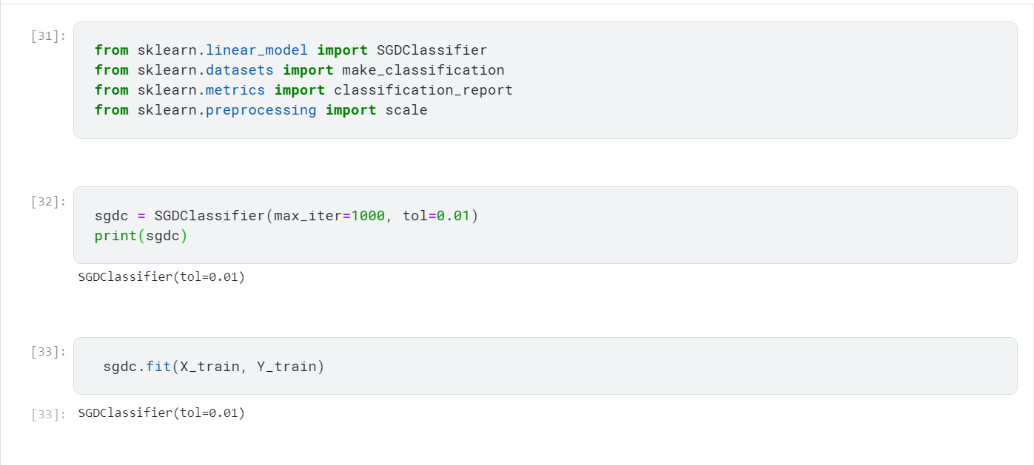

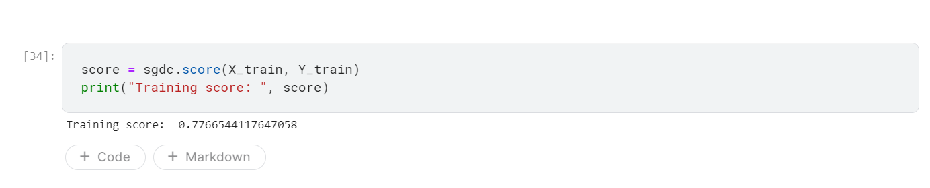

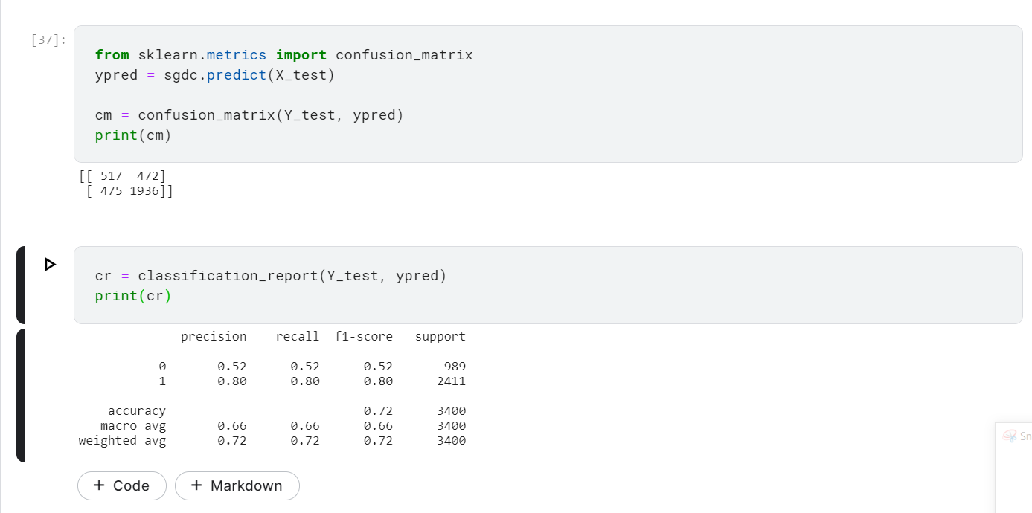

SGD Classifier gives 72% accuracy.

**Ridge Classifier**

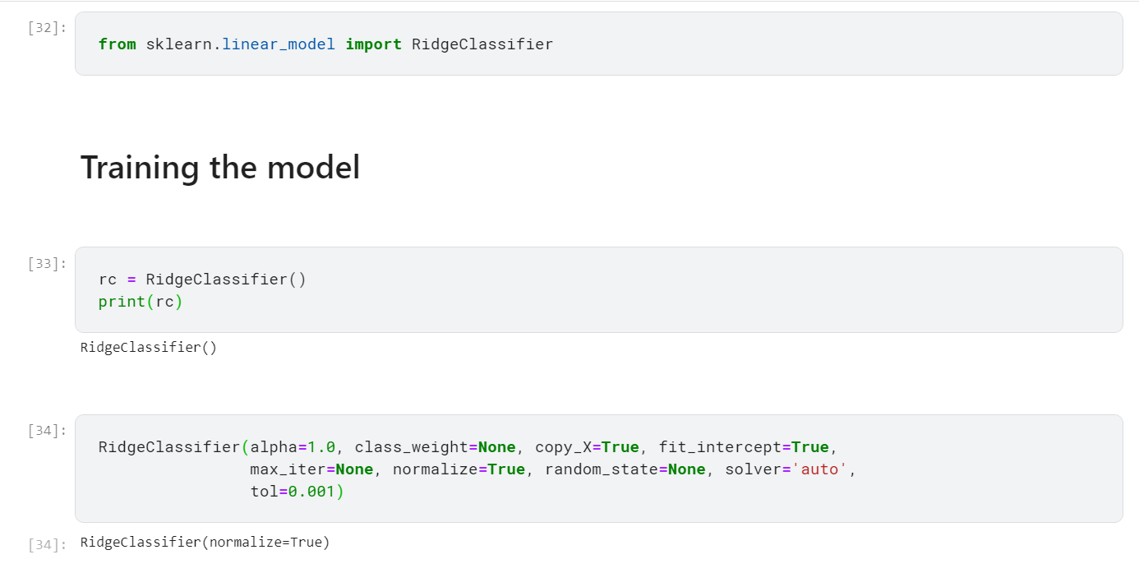

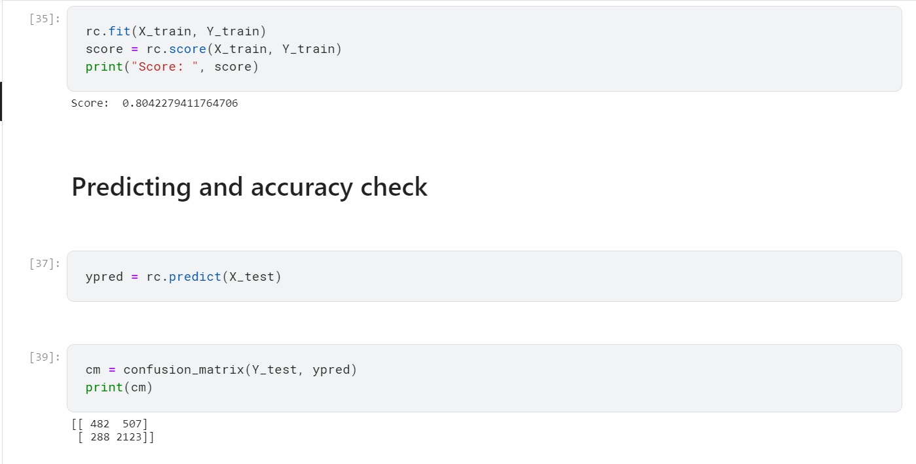

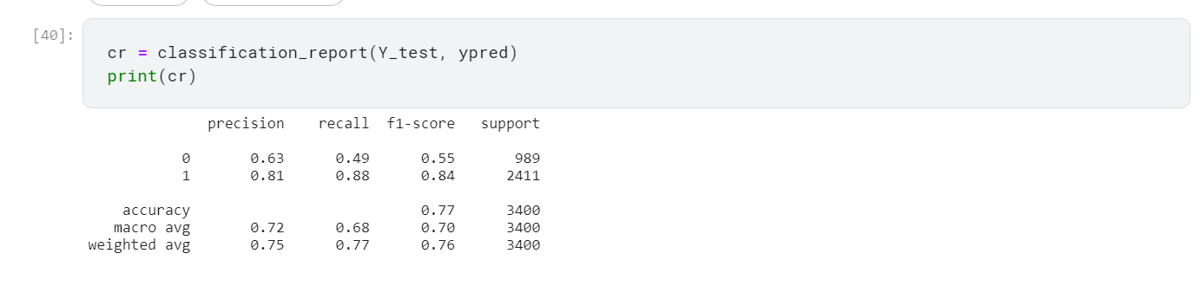

Ridge classifier gives accuracy of 77%

**Passive Aggressive Classifier**

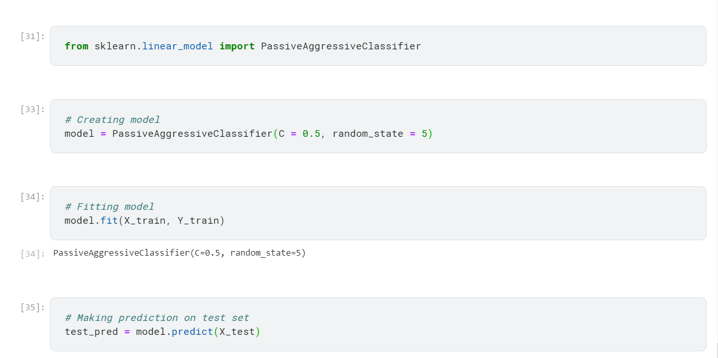

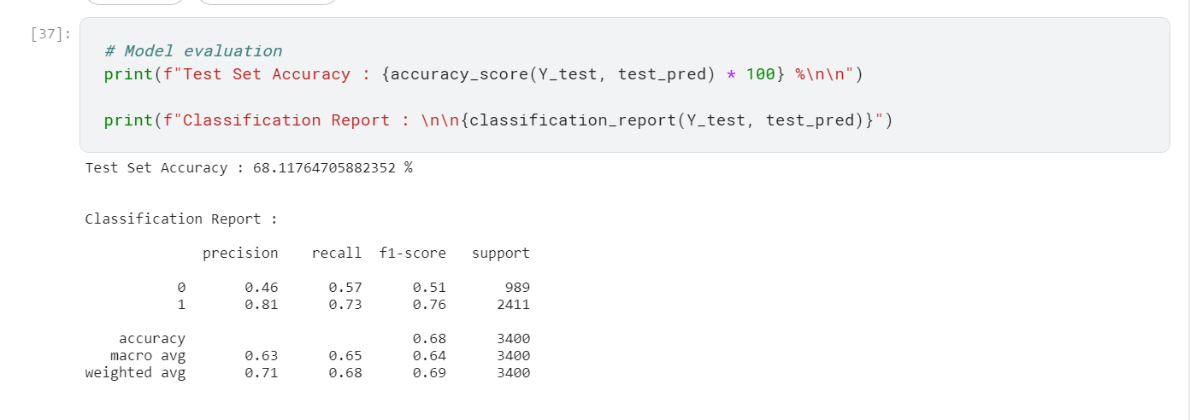

Passive Aggressive classifier give accuracy of 68%.

**Bagging Classifier**

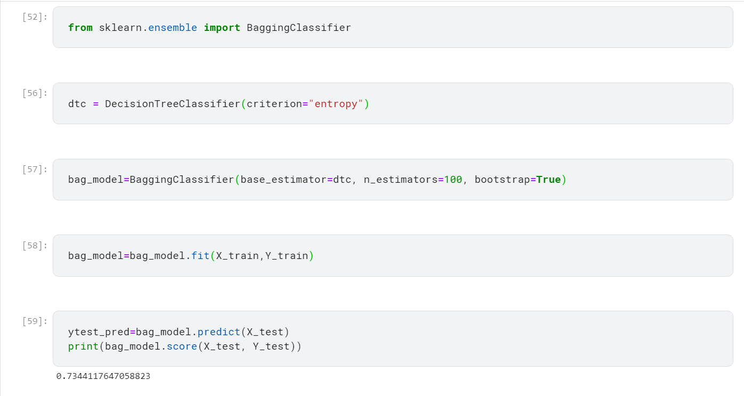

Bagging classifier has an accuracy of 73.44%

**Gradient Boosting Classifier**

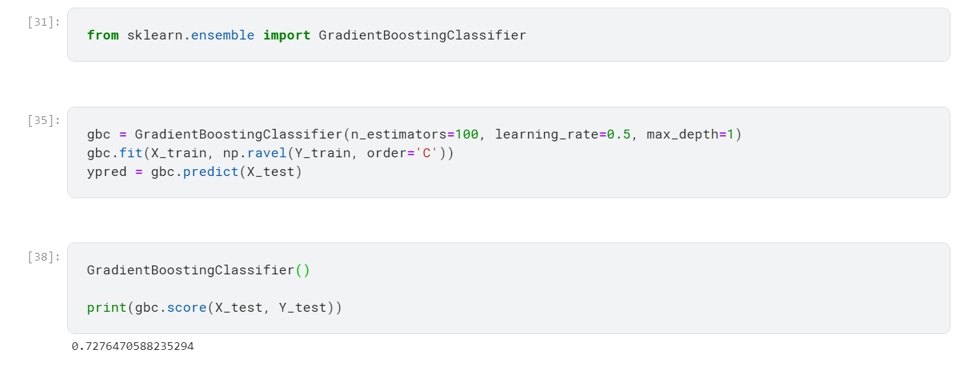

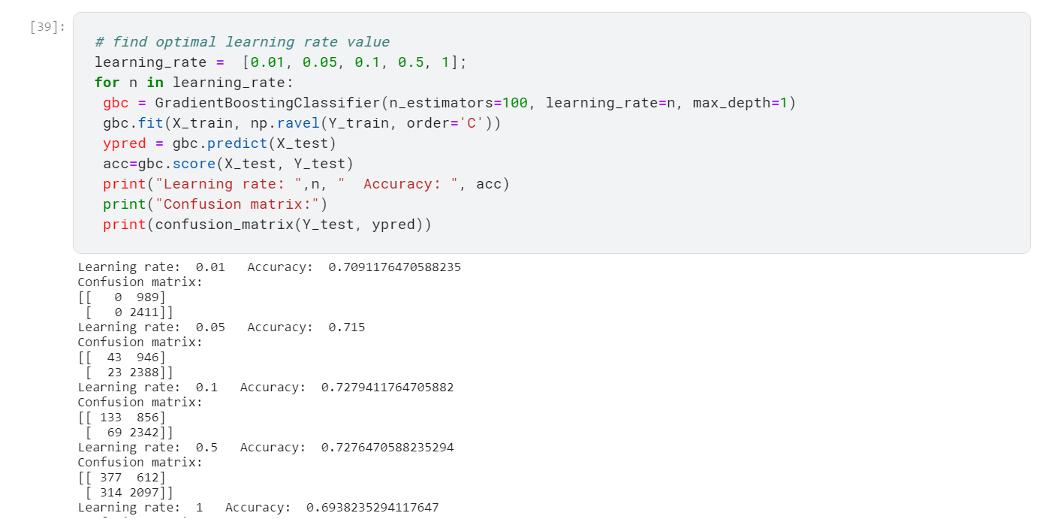

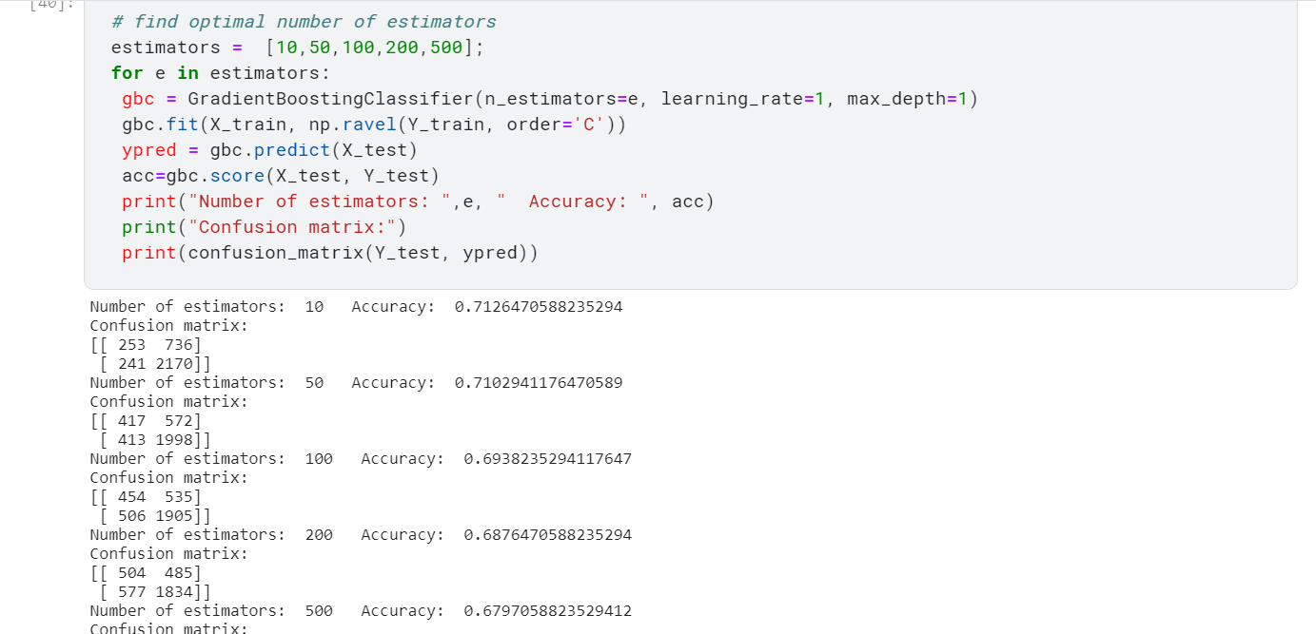

Gradient boosting classifier has an accuracy of 72.77%

**Extra Trees Classifier**

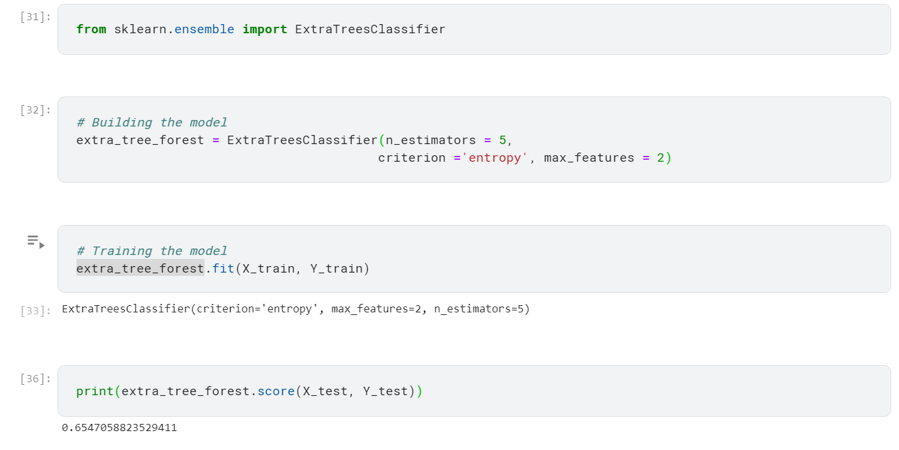

Extra trees classifier has an accuracy of 65%